**“WATCH SHOP**

**MANAGEMENT**

**SYSTEM”**



SUBMITED BY:

1. POONAM MUKESH SOMANI

2. RAJESHREE SANTOSH JADHAV



**Department Of Computer Science.**

**K.K.Wagh Arts, Commerce, Science and Computer Science College.**

**Nashik-422003**

**Academic Year2018-2019**



Karmaveer Kakasaheb Wagh Education Society’s

**K. K. Wagh Arts Commerce, Science, & Computer Science Colleg­e**

**Saraswati Nagar Nashik-422003**

**C E R T I F I C A T E**

This is to certify that,

**Miss_POONAM MUKESH SOMANI &**

**Miss RAJESHREE SANTOSH JADHAV**

has satisfactory completed their project

Watch Shop Management System as fulfillment in **T.Y.B.B.A.(Computer Application)** Class for the academic year **2018-2019**.

Project Done by: Poonam Mukesh Somani(Seat No:39903)

Rajeshree Santosh Jadhav(Seat No:39850)

Prof. V.H.Bava

Project Guide

(H.O.D )

Internal Examiner External Examiner

***ACKNOWLEDGEMENT***

We own our sincere gratitude to all those people who have given us their constant support and encouragement without which our project report would not have reached this stage.

We would like to express our thanks to Prof V.H Bava for her advice and encouragement. She has been pillar of strength right through the project till the preparation of this report and helped by boosting moral, so we could surmount the difficulties that came across during completion of this project.

We would like to express our gratitude to Dr.A.P.Rajput, Principal, K.K.Wagh Arts, commerce, science and Computer Science College. And Prof.Vijayshri Bava, Head of Computer Application department for the support and the infrastructure they have provide, so that we could successfully complete the project on time.

Last but not the list we would like to express our sincere thanks to all staff members and our friends for their help and cooperation in all phases of the project.

1. POONAM MUKESH SOMANI

(seat no:39903)

1. RAJESHREE SANTOSH JADHAV (Seat no: 39850)

**INDEX**

|  |  |  |
| --- | --- | --- |
|  | **Title** | **Page NO.** |
|  | Introduction. | **5** |
|  | Requirement Analysis | **6** |
|  | Scope of the system. | **7** |
|  | Problem Definition. | **8** |
|  | Proposed System. | **9** |
|  | Feasibility study.   1. Technical Feasibility. 2. Economical Feasibility. 3. Operational Feasibility. | **10** |
|  | System Requirements: | **12** |
|  | Diagrams:  a.Entity Relationship Diagram(ERD)  b. Data Flow Diagram (DFD)  c. Use Case Diagram  d. Class Diagram  e. Sequence Diagram  f. Component Diagram  g. Activity Diagram | **16** |
|  | Data Dictionary. | **22** |
|  | Input-Output Screen. | **25** |
|  | Future Enhancement | **28** |
|  | Conclusion | **29** |
|  | Bibliography | **30** |

**Introduction**

With tremendous increase in technology, information technology is a fast developing field. Technology which is in vogue today might become redundant tomorrow. This ever changing scenario makes it possible to provide the latest and most modern IT solutions to various business and institutions.

I am doing my project on **Watch shop Management System.** There is the need for efficient management of a network based system for handling customer orders.

This project is an endeavor to provide a solution to this. The proposed system enables an administrator to keep track of customer orders and maintaining records of the customers. He can view the submitted requirements made by the customer. He can also view the reports generated by him and can also sent approvals or rejections instantly.

Thus the project is a sincere effort in simplifying the task of administrators in an easily usable format.

I finalized to make this project and hence planned to develop this system using php /html/java script for front end and mysql as the Back End.

**Requirement Analysis**

In the projects the requirements are all which is need in a watch shop to manage to run the shop smoothly for the administrator.

1. Supplier details : To deal which supplier for purchase a products for the shop to sale customers and keep all records of with contact to supplier for future use and add more products in the shop from them. To contact al supplier who provides cosmetic products.
2. Product details : To manage all products take from supplier for customers all products name, type, price and all details which should provide to customers and keep all records of products for future . To increase shop demand in the market and aware customers for new cosmetic products to sale them.
3. Customer details : To manage all record of customers to make bill and for future use . All products name, type, price and all details which should provide to customers and keep all records of products for future . To maintain all customer details and useful for some special events or offers for the cosmetic shop .
4. Employee details : To manage all records of employees who are working in the shop their bonus and salary slips all record are maintain in the system for future use also . To maintain shop smoothly and satisfy employees too.
5. Bill reports : To manage all details of bill which are paid from the customers in which customer name, products name, type, price and all details which are essential for bill details to customers and keep all records for future . To increase shop demand in the market and aware customers for new cosmetic products to sale them.

**Scope of the System**

**Scope definition**

System scope is the part of project planning that involves determining and documenting a list of specific project goals, deliverables, tasks, costs and deadlines.

.The scope design, is often, quite different from that of the final system. The benefits of developing the software process are:

* All the records of customers and products are managed by software and it is use for future use also.
* Employees are login in the system with permission of administrator and he/she can also put records of sales and suppliers to calculate the monthly income and all.
* Some times if any thing want to change in the software it can be changed and update regularly.
* Software development is may find some time incomplete which can improve after some times in the software after using it in to market.
* A working albeit limited systems is available quickly to demonstrate the feasibility and usefulness of the application to the management.
* The scope of system serves as a basis for writing the specification for a production quality system. Though the principle purpose of prototyping is to validate software requirements, software also has other uses.
* A scope system can be used for training users before the formal system has been delivered.
* It can be run back-to-back tests. This reduces the need for tedious manual checking of test run. The same test is given to both the system under test to look for differences in the final results and thereby making necessary changes.

**Problem Definition**

* Some times records should be maintain in the system which are entered double which not giving error message so recorder should see that before inserting record in the system.
* In these system multiple products are not sale one product at a time to be sale to customer if customer want to take multiple products then the records are insert in different to maintain product details.
* The current system doesn’t allow the stock to reduce automatically so by doing sale employee should update stock details simultaneously for the records in   cosmetic shop system.
*   It requires the   cosmetic products and prices settings to cosmetic shop management system project in visual basic be done by the cosmetic shop administrator.
* In order to allow the system to work properly it should updated regularly with time to time. Cosmetic shop management system project in visual basic and ms- access are updated.
* Maintain the  cosmetic shop system information in the  products and stock system registry so that the settings can be read and written directly from suppliers.

**Proposed System**

Objective is to overcome the major limitation of the existing enabling effective management of the customer details thereby improving the performance.

* With improved computerization being involved in the maintenance of customer details, error and inconsistencies can be kept at par.
* Easy retrieval of data will be made possible by finding techniques.
* Validation of data will ensure only accurate, valid and complete data is stored in the database.
* Proper monitoring of the processes from customer registration to activation. Report generation will help make it easy to analyze the performance at the Bank.
* This will be much less time consuming comparing to existing system.

**ADVANTAGES OF PROPOSED SYSTEM :-**

* With improved computerization being involved in the maintenance of shop, product, and customer details. Error and inconsistencies can be kept at per.
* Validation of data will be ensure only accurate valid and complete data stored in the database.
* Easy retrieval or data will be made possible by finding techniques.
* Report generation will help made its easy to analyze the performance or Administration.

**OBJECTIVE AND SCOP OF PROPOSED SYSTEM:**

* The objectives of the proposed system are to overcome the major limitation of existing system enabling effective management of the customer details thereby improving the performance of SHOP ADMINISTRTION.
* The system will store all the basic data processing needs the shop management.

**Feasibility Study**

A feasibility study is undertaken to determine to the possibility or probability of either improving the existing system or developing a completely new system. It helps to obtain the overview of the problem and to get a rough assessment of whether other feasible solution exists.

NEEDS FOR FEASIBILITY STUDY:

The feasibility study is needed for following things:-

* Answer the questions whether a new system is to be installed or not?
* Determine the potential of the existing system.
* Improve the existing system.
* Know what should be embedded in the new system.
* Define the problems and objectives involved.
* Avoid costly repairs at later stage when system is implemented.
* Avoid crash implementation of the new system.
* Avoid the ‘Hardware approach’ i.e. getting a computer first and then deciding how to use it.

The Feasibility study is divided in to three parts:-

* TECHNICAL FEASIBILITY
* ECONOMIC FEASIBILITY
* OPERATIONAL FEASIBILITY
* **ECONOMIC FEASIBILITY**

Economic analysis is most frequently used for evaluation of the effectiveness of the system. More commonly known as cost/benefit analysis the procedure is to determine the benefit and saving that are expected from a system and compare them with costs, decisions is made to design and Implement the system.

This part of feasibility study gives the top management the economic justification for the new system. This is an important input to the management the management, because very often the top management does not like to get confounded by the various technicalities that bound to be associated with a project of this kind. A simple economic analysis that gives the actual comparison of costs and benefits is much more meaningful in such cases.

In the system, the organization is most satisfied by economic feasibility. Because, if the organization implements this system, it need not require any additional hardware resources as well as it will be saving lot of time.

* **TECHNICAL FEASIBILITY**

Technical feasibility centers on the existing manual system of the test management process and to what extent it can support the system.

According to feasibility analysis procedure the technical feasibility of the system is analyzed and the technical requirements such as software facilities, procedure, inputs are identified. It is also one of the important phases of the system development activities.

The system offers greater levels of user friendliness combined with greater processing speed. Therefore, the cost of maintenance can be reduced. Since, processing speed is very high and the work is reduced in the maintenance point of view management convince that the project is operationally feasible.

* **BEHAVIOURAL FEASIBILITY**

People are inherently resistant to change and computer has been known to facilitate changes. An estimate should be made of how strong the user is likely to move towards the development of computerized system. These are various levels of users in order to ensure proper authentication and authorization and security of sensitive data of the organization.

**System Requirement**

Software requirement:

All the tables and data which is used in the software are follows for system requirement which are used in PHP for the front end and the tables are in the MySQL for back end. User and administrator of the system are work on these follows things for customer and shop requirements .

**Forms Used :**

|  |  |  |
| --- | --- | --- |
| **Sr.No.** | **FORM-NAME** | **DESCRIPTION** |
| 1. | Front page | It is the main form. It contains all the menu items. |
| 2. | Supplier | It is the main form containing Product details. |
| 3. | Customer | It is the main form containing Customer details. |
| 4. | Products | It gives information about the available products for customers. |
| 5. | Bill | It contains details about the Last Bill Generated. |
| 6. | Login | It helps to enter the software if the correct login name and password is entered. |
| 7. | Employee | It gives details about the Employees. |

**Table Used :**

|  |  |  |
| --- | --- | --- |
| **SR.NO.** | **TABLE NAME** | **DESCRIPTION** |
| 1. | Supplier | It contains data of all the Products get for shop. |
| 2. | Employee Details | It contains data of all the Employees. |
| 3. | Customer | It contains data of all the Customers. |
| 4. | Products | It contains all details of products available in the shop . |
| 6. | Bill | It contains data of Bills. |
| 7. | Login | It contains data valid users. |

**Report List :**

|  |  |  |
| --- | --- | --- |
| **SR.NO** | **REPORT NAME** | **DESCRIPTION** |
| 1. | Billing | It gives the report of generated Bills. |
| 2. | Employee | It gives the report of all the employee details. |
| 3. | Products | It gives the report of available stock/products. |
| 4. | Customer | It gives the report of customer details for future use. |
| 5. | Supplier | It gives the report of supplier or dealers for getting products in shop. |

**Pseudo Code :**

|  |  |  |  |
| --- | --- | --- | --- |
| **SR.NO.** | **NAME** | **Procedure** | **DESCRIPTION** |
| 1. | Add | Click | Add new Records |
| 2. | Update | Click | Update Current Record |
| 3. | Delete | Click | Delete Current Record |

Hardware requirement:

Hardware requirements are less in the system are :

Processor Pentium Class processor

RAM: 16 MB or above

Hard Disk space: 2.1 G. B

Mouse Drivers

Keyboard

Colour Monitor

Printer

**Diagrams**

**ENTITY RELTIONSHIP DIAGRAM (ERD)**

**Entity-Relationship Diagram**

* This document is an entity-relationship diagram, or “ERD,” for a system to manage Inventory Management System.
* An ERD is a model that identifies the concepts or entities that exist in a system and the relationships between those entities.
* An ERD is often used as a way to visualize a relational database: each entity represents a database table, and the relationship lines represent the keys in one table that point to specific records in related tables.
* ERD may also be more abstract, not necessarily capturing every table needed within a database, but serving to diagram the major concepts and relationships.
* This ERD is of the latter type, intended to present an abstract, theoretical view of the major entities and relationships needed for management of electronic resources.
* It may assist the database design process for an e-resource management system, but does not identify every table that would be necessary for an electronic resource management database.

**ERD**

M

Has

Employee

Watch Shop

1

1

1

Demand

Manage

M

Supplier

M

M

Customer

1

1

Provide

M

Product

M

M

Purchaseee

Has

Pay

1

1

Bill

**Data Flow Diagram (DFD)**

A **data flow diagram** (**DFD**) is a graphical representation of the "flow" of data through an [information system](http://en.wikipedia.org/wiki/Information_system). DFDs can also be used for the [visualization](http://en.wikipedia.org/wiki/Data_visualization) of [data processing](http://en.wikipedia.org/wiki/Data_processing) (structured design).

Data FlowDiagram

0.0

Generate

Employee

Insert records

Employee

Update, delete records

Product, customer

Supplier, bill

reports

CUSTOMER DETAILS

**Customer**

**CUSTOMER**

**DETAILS**

**1.0**

**Customer**

**Customer Information**

**Customer**

**Detail**

**ACCOUNT**

**1.1**

**ADD**

**ACCOUNT**

**Customer**

**1.1**

**ADD**

**Customer**

**Customer**

**1.3**

**DELETE**

**Customer**

**Customer**

**1.2**

**UPDATE**

**Customer**

Display Information

Add record

Display Information

Update record

Display Information

Delete record

**Use Case Diagram**

A use case specifies the behavior of a system or a part of a system. Use case is a description of a set of sequence of actions including variants that a system performs to yield an observable result of value to an actor.

A use case represents a functional requirement of the system. A use case involves the interaction of actors and the system.

<<include>>

<<uses>>

Supplier, product

Customer,

Bill

employee

<<purchase>>

<<provide>>

<<purchase>>

Watch shop

customer

**Class Diagram**

The class diagram is a static diagram . It represent the static view of an application or a system. It describes the attribute and operations of a class and also the constraints imposed on the system.

**Watch Shop**

**Employee**

+shopno:integer

+sname:string

+address:string

+mobileno:integer

+email:string

+eno: integer

+ename: string

+address: string

+mobileno: integer

+email: string

1

checkreports()

1

1

+add_employee()

+delete_employee()

+update_employee()

+generatereport

+*

1

**supplier**

+*

+sno:integer

+sname:string

+mobileno:integer

+date-of-purchase:date

+productname:string

+price:integer

+brand:string

**Customer**

+cno: integer

+cname: string

+address: string

+mobileno: integer

+email: string

+*

+add_supplier()

+delete_supplier()

+update_supplier()

+generatereport

+add_customer()

+delete_customer()

+update_customer()

+generate report

+*

1

1

+*

**Product**

**Bill**

+pno: integer

+pname: string

+category: string

+brand: string

+price: integer

+bno: integer

+productname: string

+customername: string

+bill_date: date

+price: integer

+*

+add_product()

+delete_product()

+update_product()

+generate report

+add_bill()

+delete_bill()

+update_bill()

+generate report

**Sequence Diagram**

A sequence diagram emphasizes the time ordering of messages. It is an interaction diagram that show how processes operate with one another and in what order. It is a construct of message sequence chart.

**Bill**

**product**

**customer**

**Employee**

**Watch shop**

1.Login

7.genearte bill

5.Buy product

4.add customer

2.provide admin page

3.visit customer

8.make payment

6.add product

10.generate report

9.print bill

**Component Diagram**

Component diagram shows organizations and dependencies set of components . componenet diagram describe the organization of physical software components , including source code , run –time code and executables.

Add record

Employee

Delete record

Update record

customer

Generate bill

product

**Activity Diagram**

An activity diagram is essentially a flowchart , showing flow of control from activity to activity the activity diagram can be described as an operation of the system.

start

Employee

yes

Login

No

Valid user

Make Bill

Manage customer

Manage product

Manage supplier

Pay bill

provide product

Generate report

End

**Data Dictionary**

1. Shop Details:

|  |  |  |
| --- | --- | --- |
| Name | Discription | Type |
| Shop-no | Primary Key | varchar(5) |
| Shop-name |  | varchar(20) |
| Mobile-no |  | Number(10) |
| Address |  | varchar(20) |
| Email-id |  | varchar(15) |

1. Login Details:

|  |  |
| --- | --- |
| Name | Type |
| UserName | varchar(15) |
| Password | varchar(15) |

1. Employee Details:

|  |  |  |
| --- | --- | --- |
| Name | Description | Type |
| Eid | Primary Key | varchar(5) |
| Ename |  | varchar(20) |
| Address |  | varchar(20) |
| Mobileno |  | varchar(12) |
| Salary |  | Number(10) |
| Email |  | varchar(10) |

1. Supplier Details:

|  |  |  |
| --- | --- | --- |
| Name | Discription | Type |
| Sno | Primary Key | varchar(5) |
| Sname |  | varchar(20) |
| Mobileno |  | Number(10) |
| Productname |  | varchar(20) |
| Quantity |  | varchar(10) |
| Date-of-Purchase |  | Date |
| Price |  | Number(10) |
| Eid | Foreign Key | varchar(5) |

1. Product Details:

|  |  |  |
| --- | --- | --- |
| Name | Discription | Type |
| Pno | Primary Key | varchar(5) |
| Productname |  | varchar(20) |
| Expiry-Date |  | Date |
| Discription |  | varchar(20) |
| ProductType |  | varchar(15) |
| Price |  | Number(10) |
| Eid | Foreign Key | varchar(5) |

1. Many-to –Many of Customer & Product Details:

|  |  |  |
| --- | --- | --- |
| Name | Discription | Type |
| Cno | Foreign key | varchar(5) |
| Pno | Foreign key | varchar(5) |

1. Customer Details:

|  |  |  |
| --- | --- | --- |
| Name | Discription | Type |
| Cno | Primary Key | varchar(5) |
| CustomerName |  | varchar(20) |
| Address |  | varchar(20) |
| Date-of-Birth |  | Date |
| Mobileno |  | Number(10) |
| Eid | Foreign key | varchar(5) |

1. Bill Details:

|  |  |  |
| --- | --- | --- |
| Name | Discription | Type |
| Bno | Primary Key | varchar(5) |
| Customer name |  | varchar(20) |
| Productname |  | varchar(20) |
| Quantity |  | varchar(10) |
| Expiry-Date |  | Date |
| Price |  | Number(10) |
| Date-of-bill |  | Date |
| Total Amount |  | Number(10) |
| Cno | Foreign key | varchar(5) |
| Sno | Foreign key | varchar(5) |

Input-Output Screen

1. Employee details: which add,delete,save and update all the record of employees in the system.

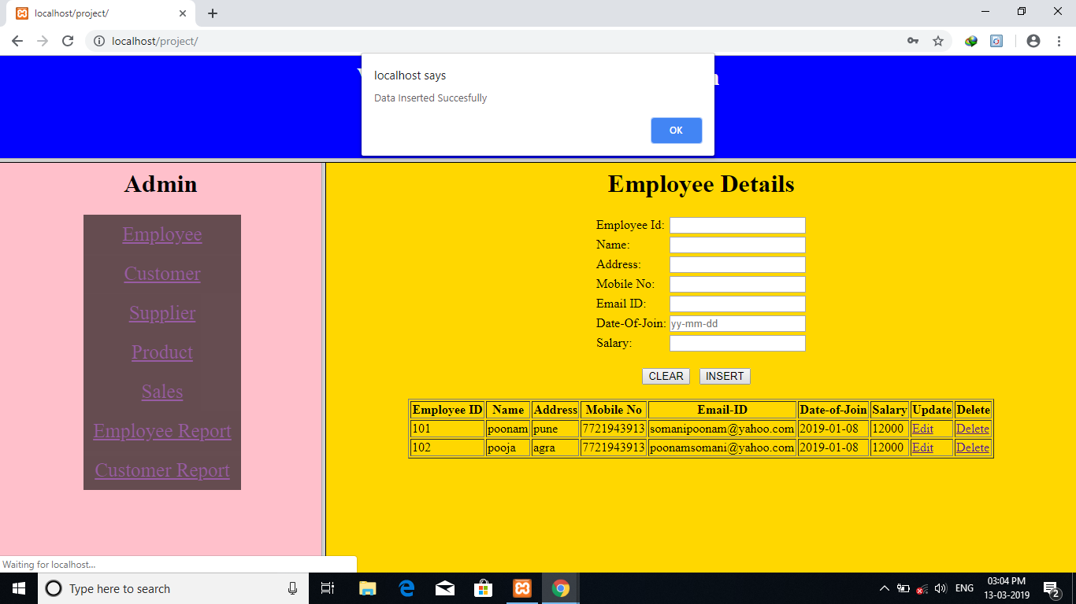

1. Product details: which add, delete, save and update all the record of Products in the system

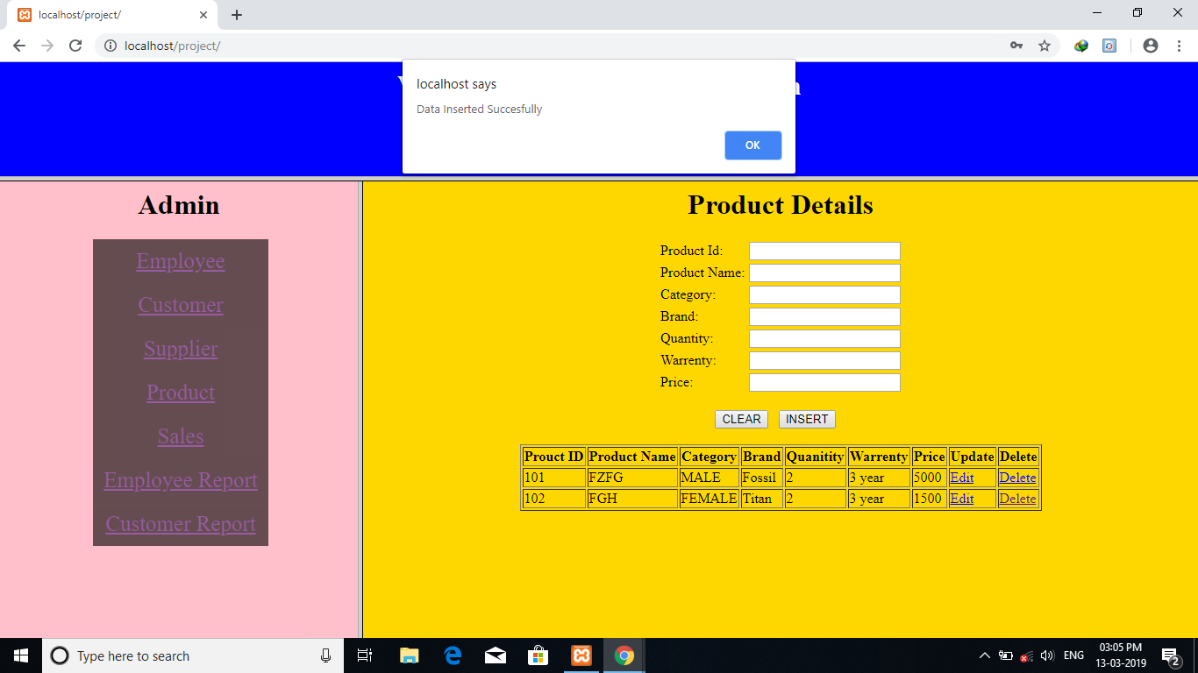

1. Bill details: which add, delete, save and update all the record of Bill in the system.

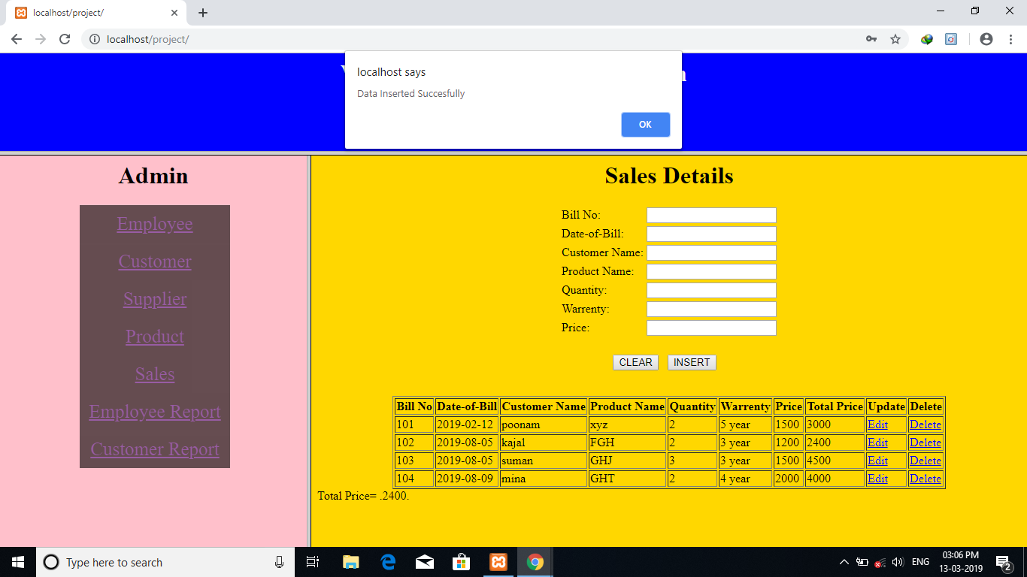

1. customer details: which add, delete, save and update all the record of customer in the system.

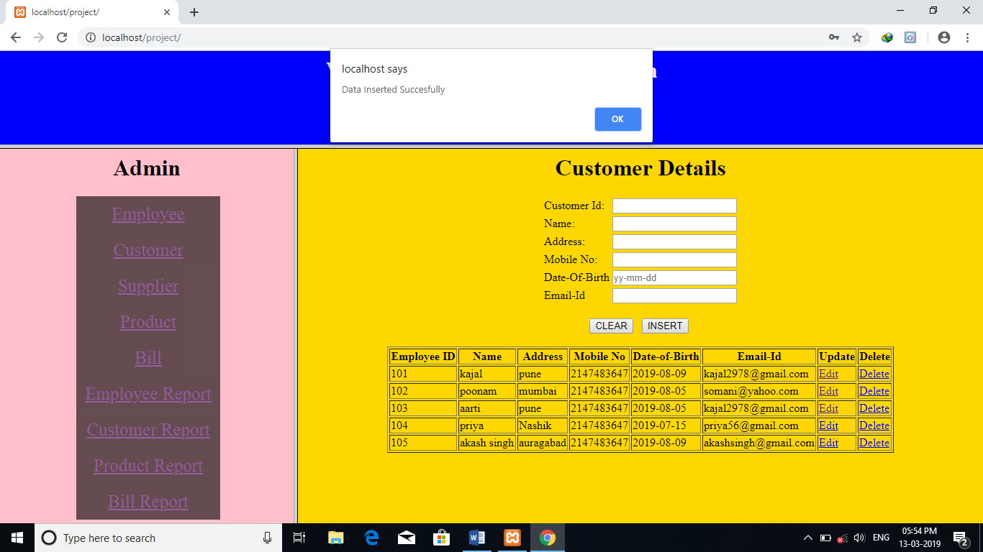

Report Screen

1. Bill Report:

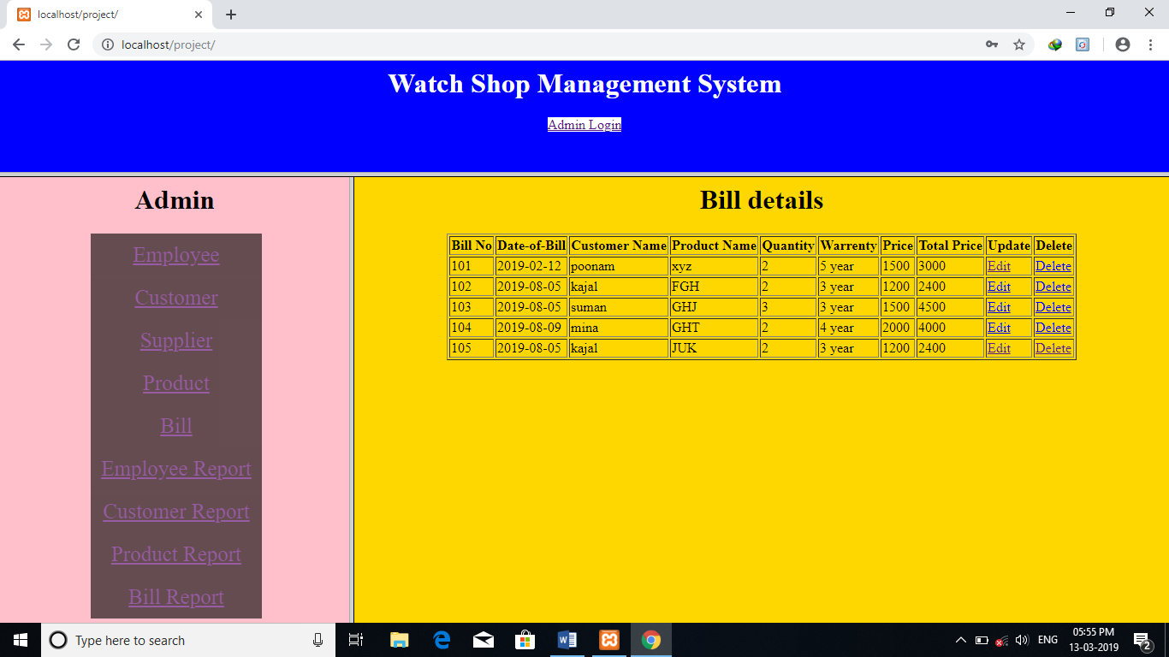

1. Customer Report

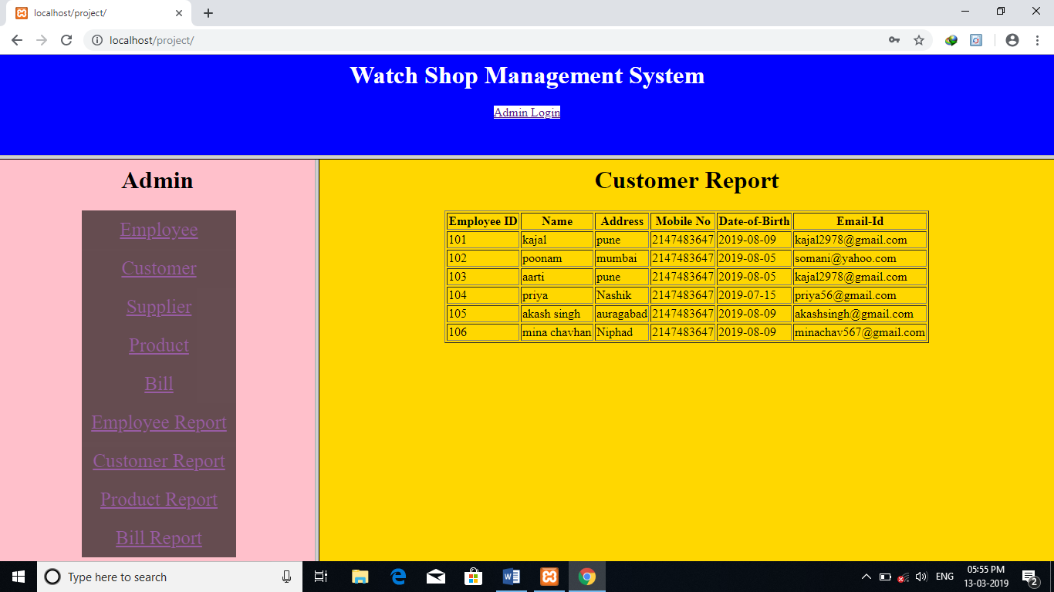

Future Enhancement

Project future enhancement and objective some of them are:-

* All the processes of this management are done manually in the form of paper work and the records are stored in the registers. In such cases there are frequent chances of data redundancy and data is ease to lose.
* All the introductions related to the patients and others printed on the papers, this activity generates the chances of data lost.
* All the bills structures are done by hand written; sometimes it produces mistakes in calculation.
* This system is very time consuming and require lot of manpower

**CONCLUSION**

The demand for application is increasing day by day in Software industry, due to high expectations of client companies.

Hence an attempt of automating an office application had added to our learning experience.

It has also helped in adopting an analytical approach to solving and made us realize that system development is a step by step process,

Thereby appreciating the role of SDLC model in organizing the complex process of system development into manageable chunks. Indeed it was a great learning experience.

**Bibliography**

1. Guide to programming in PHP:

-Book by

Mrs .SHALAKA SAKHREKAR

(NIRALI PRAKASHAN )

1. MYSQL:

-By Korth

-By Elmasuri an Navathe

3. Data Base System:

-By Shamkani and B Navathe

Project Management system form Internet and You tube.